press release 3

IBE 2024 AND INTERMOBILITY FUTURE WAYS:
THE INNOVATION DISTRICT FOR START-UPS AND INNOVATIVE SMES

- The new IBE Innovation District with four specific tracks: Innovation, Start-ups, Education & Job Orientation, Talks
- In the spotlight the “Lorenzo Cagnoni for Innovation” Awards assigned to the three most innovative projects submitted by the exhibitors of IBE and INTERMOBILITY future ways and “Innovative Start-up Lorenzo Cagnoni” reserved for the ten innovative companies featured in the Innovation District

Rimini, 19-21 November 2024 – IBE Intermobility and Bus Expo, the biennial event curated by IEG Italian Exhibition Group with the support of ASSTRA and AN.BTI CONFCOMMERCIO, running at Rimini Expo Centre from November 19 to 21, focuses on innovation, in conjunction with ANGI (National Association of Young Innovators), the Green&Tech division of IEG Italian Exhibition Group, with the support of the Foundation for Sustainable Development, EIT Urban Mobility(**) and the Rimini Technopole within the INNOVATION DISTRICT.

In the event’s 11th edition, the INNOVATION DISTRICT is divided into four specific tracks dedicated to innovative Italian and international Start-ups and SMEs. Set up in the prestigious Lorenzo Cagnoni Cupola of the IEG Rimini Expo Centre, exhibitors showcase the latest innovations in mobility focusing on collective urban transport, tourist bus travel, new energy sources, digital technologies, shared mobility services, MaaS and mobility management.

THE FOUR TRACKS
- The “Innovation” track is reserved for exhibitors presenting their new releases, the most innovative products and competing for the “Lorenzo Cagnoni for Innovation” Award;
- The “Start-up” track is dedicated to young companies, in other words start-ups and innovators who have developed unique and cutting-edge solutions for shared sustainable mobility;
- The “Education&Job Orientation” track is a series of round tables dedicated to students and the industry focusing on training needs and new and old jobs related to sustainable mobility, with discussions, proposals and ideas aimed at creating new business and networking opportunities;
- The “Talks” track is an “interview corner” to collect the experiences of the most innovative companies and the main stakeholders of the event.

THE “START UP&SCALE-UP” AREA
The “Start-Up&Scale-Up” area fosters an exchange of ideas between established companies and emerging companies, offering them visibility both nationally and internationally.
The interested start-ups and innovative SMEs involved have projects in the following market segments:
- Smart Mobility (smart solutions for urban and interurban transport)
- Sharing Mobility (platforms and technologies for car sharing, bike sharing, ride sharing and on-demand transport)
- Cloud (cloud computing services for data management and analysis)
- Artificial Intelligence (AI applications in the mobility industry)
- Industrial Software (software for the automation and management of industrial processes)
- Smart Energy (smart energy solutions for vehicles and infrastructures)
- Smart Payment (innovative payment systems for public transport)
- Automotive Industrial (technologies and solutions for the automotive industry)
- IoT (The Internet of Things applied to mobility)
- Cyber ​​Security (cyber security solutions for the transport industry)
- Circular Economy & ESG (projects and solutions for environmental and social sustainability)
- Wearables (wearable devices for monitoring and controlling mobility).

The applications were assessed by a committee of experts made up of IEG, Foundation for Sustainable Development, EIT Urban Mobility, Rimini Technopole, by selected members within the Intermobility Community and by the network of partners of the initiative based on a series of criteria such as the innovativeness of the product or service, collaborations and partnerships, its industrialisation and readiness for the market. Compatibility with the exhibition sectors of IBE and Intermobility Future Ways was also taken into account.
10 start-ups were selected for the 2024 edition: FAIRTIQ, Gremobo, Parkforfun, REDOMAP, REMOTED OY, SAFETECOM, SDS SAFETY DRIVING SOLUTIONS, THEBELLBOY, WAYLA.

INNOVATION AWARDS
On November 19, for the first time, two awards will be presented: the “Lorenzo Cagnoni for Innovation” Award dedicated to the memory of the late IEG President Lorenzo Cagnoni, reserved for the three most innovative projects proposed by exhibitors at IBE and Intermobility future ways; the “Lorenzo Cagnoni Innovative Start-up” Award reserved for young, cutting-edge companies present in the INNOVATION DISTRICT.

The projects were assessed by the Evaluation Committee set up by IEG and the network of partners of the initiative.

EIT Urban Mobility (**) is an initiative of the European Institute of Innovation and Technology (EIT). A growing pan-European partnership that brings together businesses, educational institutions, research excellence centres and multi-faceted cities. Its aim is to facilitate and finance collaboration between these players to create mobility solutions that accelerate the transition towards more liveable urban spaces.

PRESS CONTACT - ITALIAN EXHIBITION GROUP
head of media & corporate communication: Elisabetta Vitali; press office manager: Marco Forcellini, Pier Francesco Bellini; international press office coordinator: Silvia Giorgi; press office coordinator: Luca Paganin; press office specialists: Nicoletta Evangelisti, Mirko Malgieri; media@iegexpo.it

MEDIA AGENCY
Twister communications group
Patrizia Vallecchi, +39 335 6334169 - pvallecchi@twistergroup.it
Monica Cipparrone - +39 349 2814894 – mcipparrone@twistergroup.it
Andrea Franceschi - +39 3357485194 - afranceschi@twistergroup.it

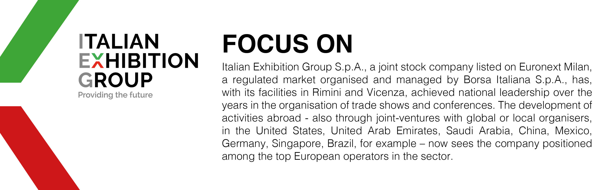

This press release contains forecast elements and estimates that reflect the management’s current opinions (“forward-looking statements”), particularly regarding future management performance, realization of investments, cash flow trends and the evolution of the financial structure. For their very nature, forward-looking statements have a component of risk and uncertainty, as they depend on the occurrence of future events. The effective results may differ (even significantly) from those announced, due to numerous factors, including, only by way of example: food service market and tourist flow trends in Italy, gold and jewellery market trends, green economy market trends; the evolution of raw material prices; general macroeconomic conditions; geopolitical factors and evolutions in the legislative framework. Moreover, the information contained in this release does not claim to be complete, and has not been verified by independent third parties. Forecasts, estimates and objectives contained herein are based on the information available to the Company as at the date of this release.

